Application Deployment
(Deploy the given React application to a production ready state)

Application:
Clone the below mentioned repository and deploy the application (Run application in port 3000).
Repo URL : https://github.com/Vennilavan12/Brain-Tasks-App.git

Docker:
- Dockerize the application by creating Dockerfile
- Build an application and check output using docker image.
ECR:
- Create an AWS ECR repository for store docker images.
Kubernetes:
- Setup Kubernetes in AWS EKS and Confirm EKS cluster is running.
- Write deployment and service YAML files.
- Deploy using kubectl via Codedeploy.
CodeBuild:
- Create a CodeBuild project:
- Source: Connect to your repository
- Environment: Use managed image (Amazon Linux, Ubuntu)
- Write and define commands in buildspec.yml.

CodeDeploy:
- Create codedeploy application.
- create appspec.yml file to deploy applications in EKS.

Version Control:
- Push the codebase to a Git provider (GitHub).
- Use CLI commands to push code.

CodePipeline:
- Source: GitHub
- Build: AWS CodeBuild project
- Deploy: AWS CodeDeploy or deploy to EKS via Lambda or custom script.
Monitoring:
- Use CloudWatch Logs to track build, deploy, and application logs.
Submission Guidelines:
- GitHub Link: Submit full code repository.
- README File: Include setup instructions, pipeline explanation, and screenshots or create a document and attach all screenshots.
- Application deployed kubernetes Loadbalancer ARN.

===========OUT-PUT SCREEN SHOT ======================
- Push the codebase to a Git provider (GitHub). Used CLI commands to push code.
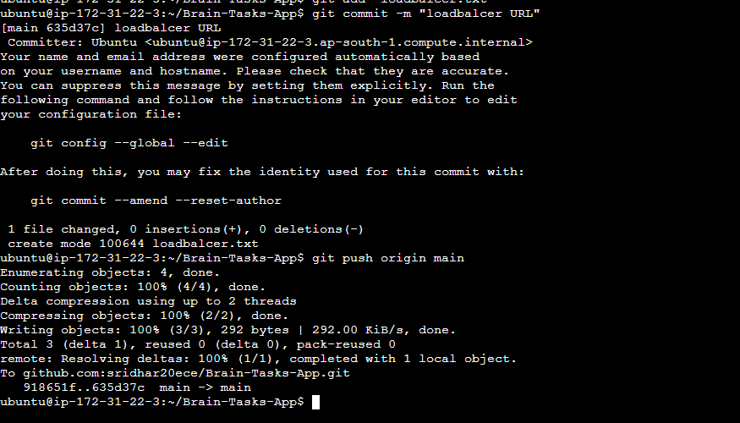
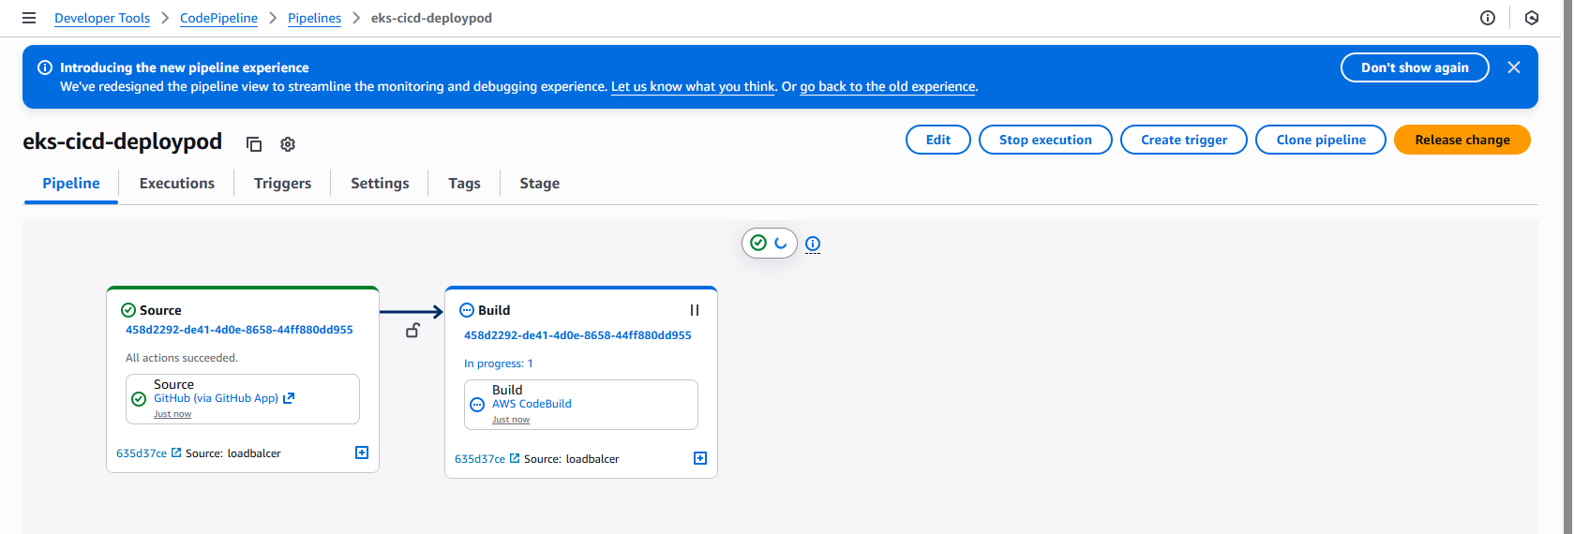

1. ECR images Push
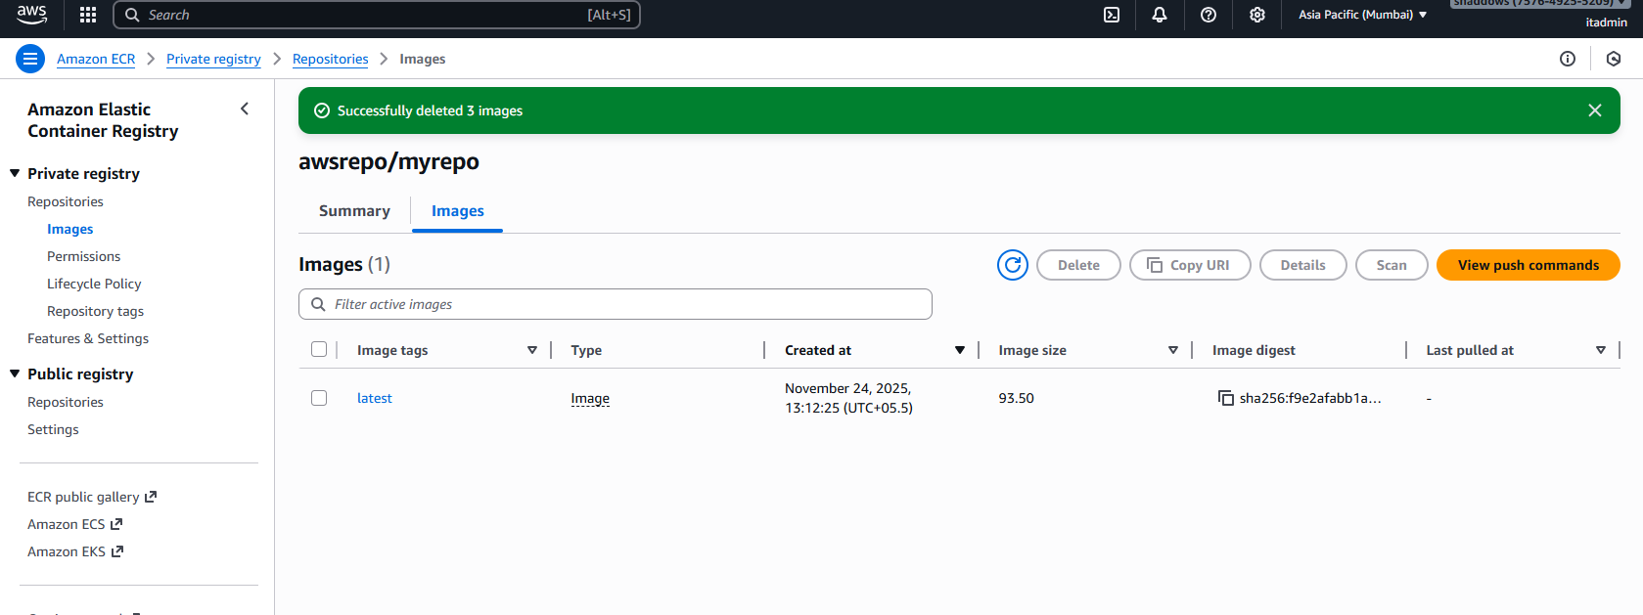
2. EKS nodes and service
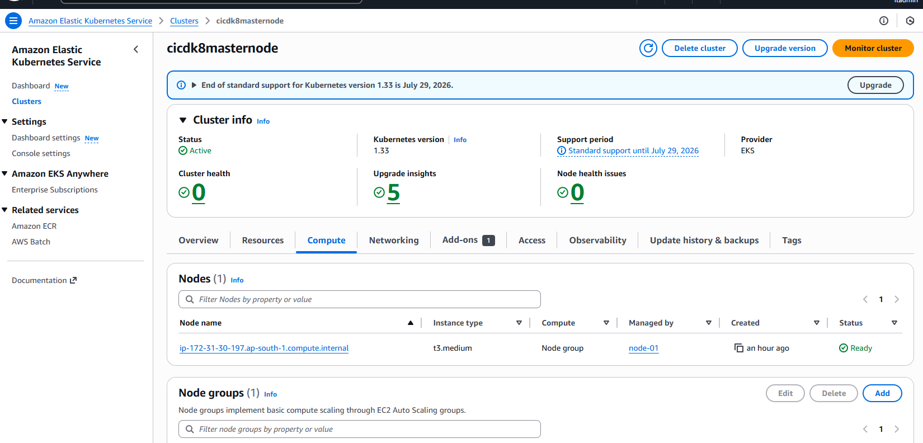
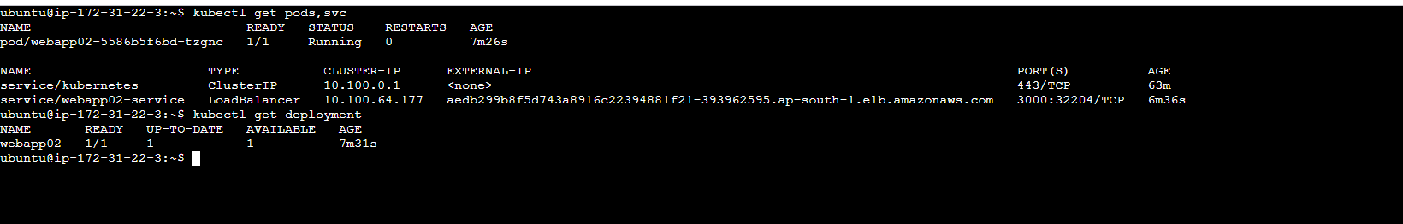
3. codepipeline success
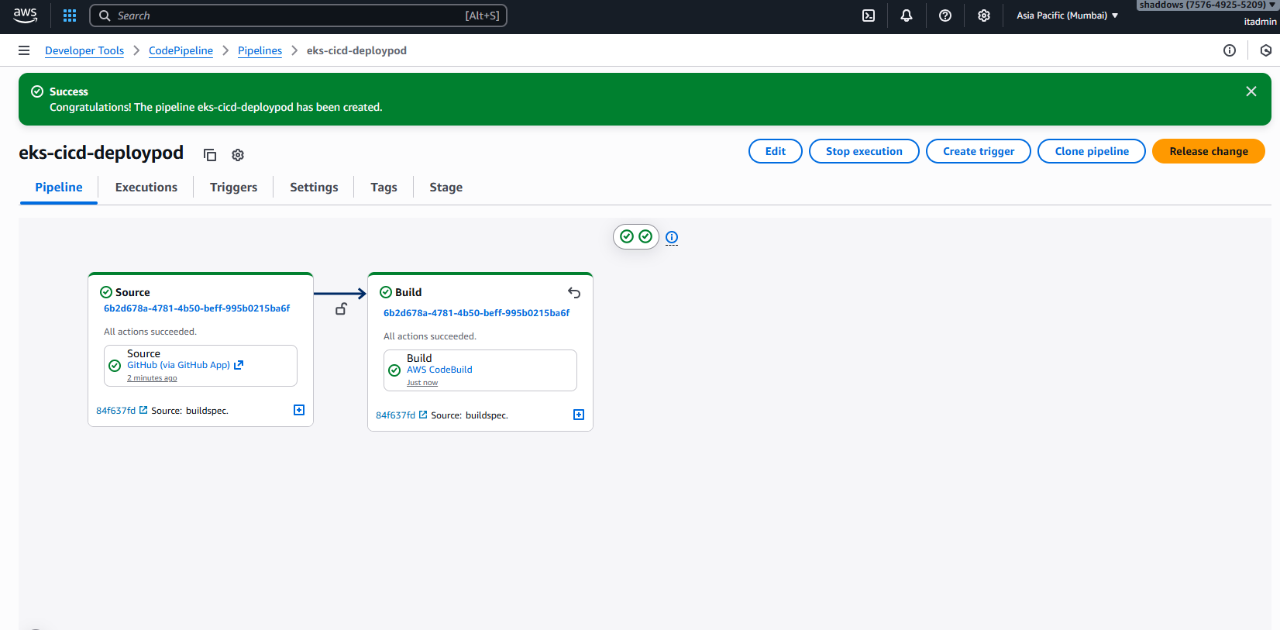
4.App running via LoadBalncer URL
http://aedb299b8f5d743a8916c22394881f21-393962595.ap-south-1.elb.amazonaws.com:3000/
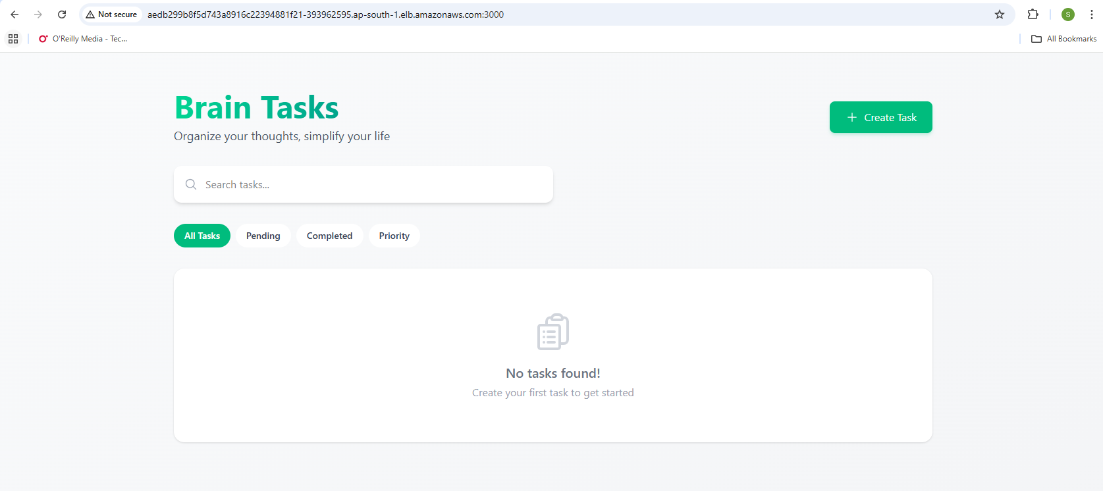
#Monitored:
1.CodeBuild Logs ==> Build Phase output
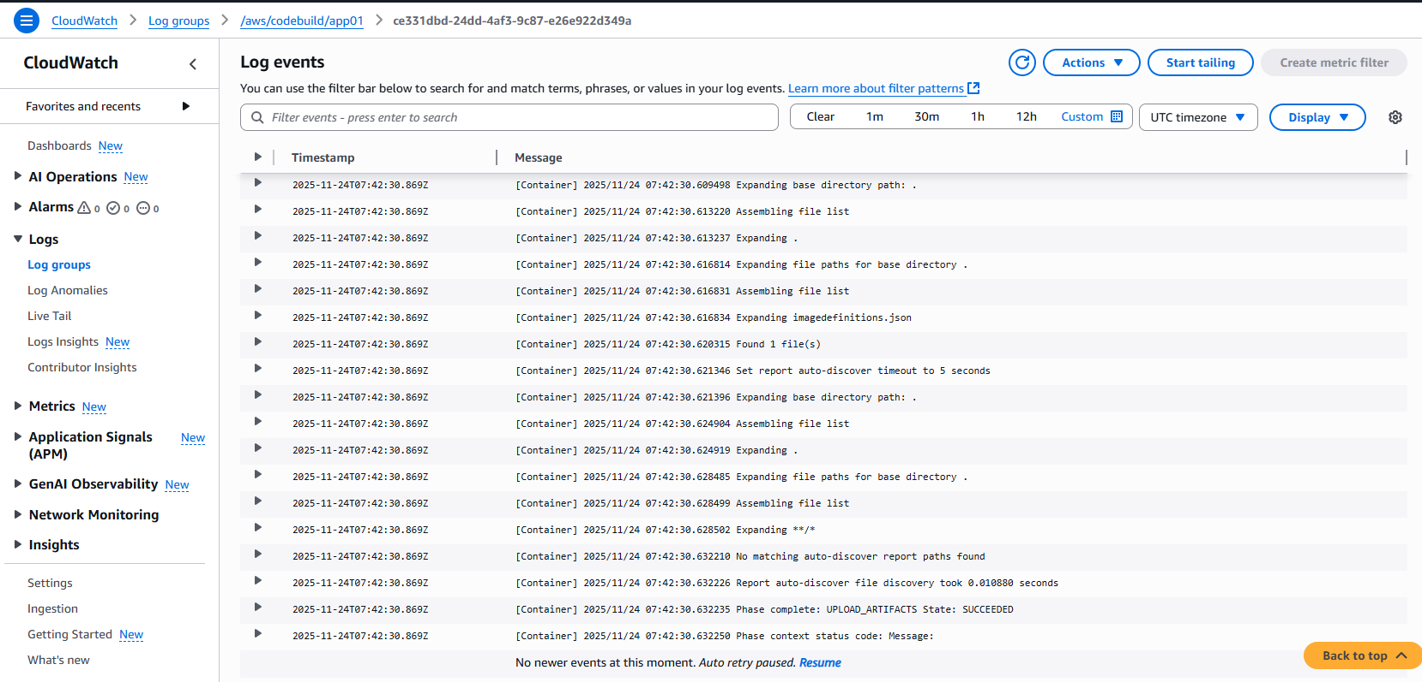
2.CodeDeploy Logs ==> Deployment steps.
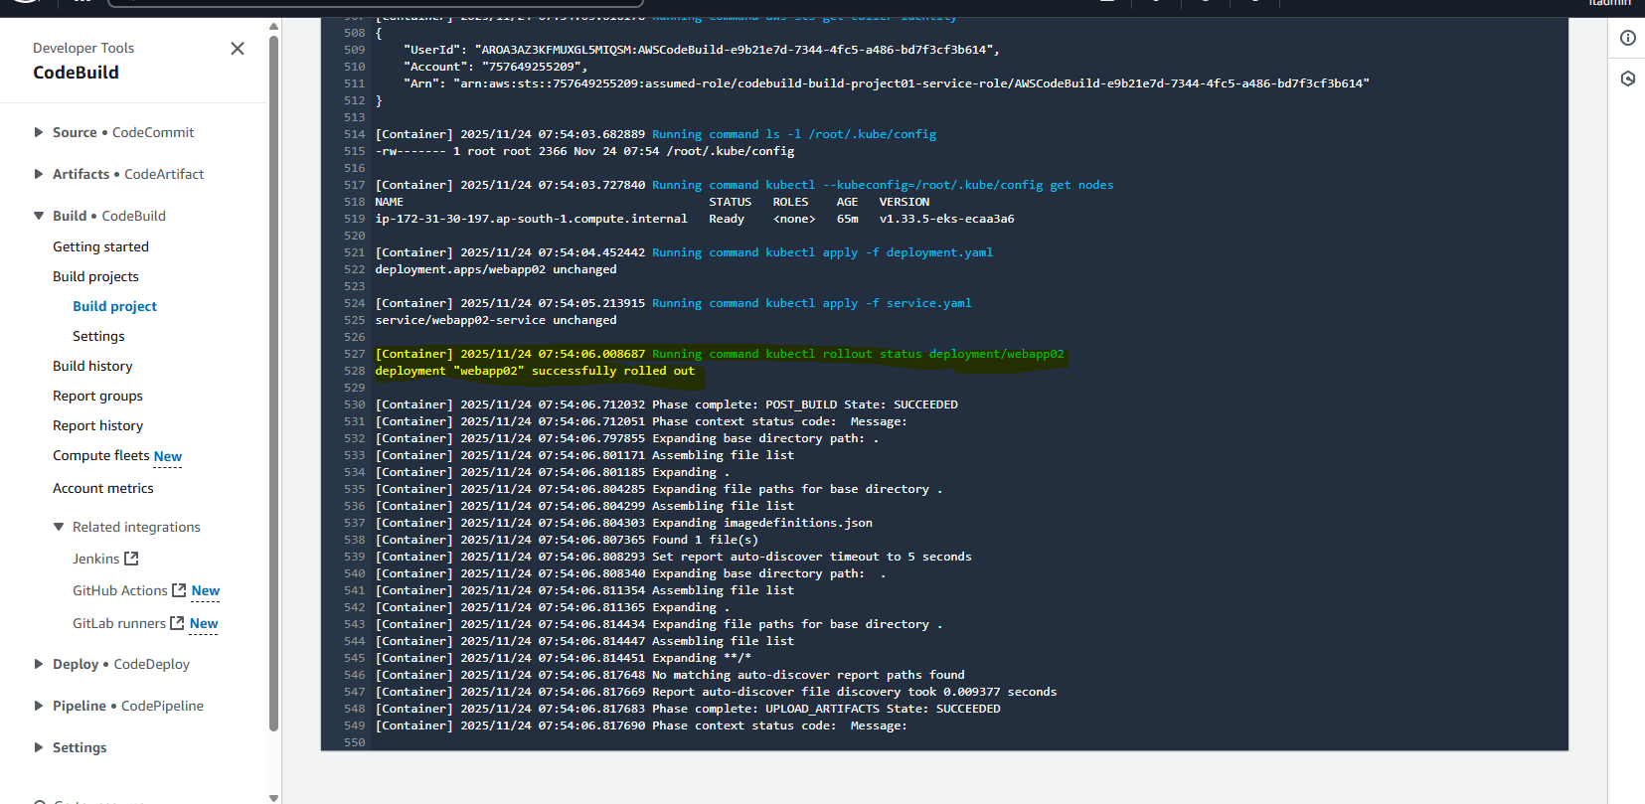
3.Application Logs ==> Via POD stdout(kubectl logs).

Note: Work flow More Screen shots
Application Deployment01-work-flow.docx

